Technical Analysis: A DIGITAL PEN
Michael W. Shenouda
Department of English, CUNY: The City College of New York
ENG 21007: Writing for Engineers
Prof. Julia Brown
March 23, 2021

Table of Contents
Definition.........................................................................................................................................3
Overview..........................................................................................................................................3
Components... ..................................................................................................................................4
Explanantion....................................................................................................................................4
Visuals…..........................................................................................................................................5
Conclusion.......................................................................................................................................6
References........................................................................................................................................7

What is a Digital Pen?
A digital pen is a device that is used on touchscreen surfaces, such as tablets, touchscreen laptops which include the technology inside of them that supports the pen so, the computer can capture the input of the pen, whether it’s handwriting, drawing, selecting files with it, etc. There are a variety of them, and each one has different structures and abilities and different designs.

Overview
As mentioned before these pens come in a variety of designs and functions. Most of these pens sizes, functions, colors, etc. can differ depending on the company manufacturing them. Most companies have a variety of colors for costumers to choose from. Most companies use a 4 A battery size for their pen’s battery, or they are rechargeable pens. Most digital pen’s height will be around 5.8 inches, and the width will be around 0.40 inches, however, all these measurements depend on the company manufacturing them. Also, they usually weight about 20.0 grams. A digital pen’s cost will be in the range of $29.99 to $199.99 dollars, depends on the built in. All digital pens can be viewed as a regular pen with a pointy end at the end but in a much more advanced way.
A normal pen: A digital pen: 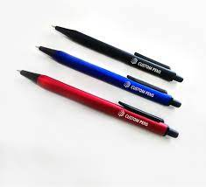 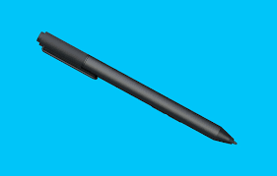(Microsoft pen)

Components
The most common components of a digital pen:
- A digitizer/Sensing Tip
- A small Circuit Board
- A battery storage area
- A multitasking button(optional)
- A turn on/off button
Explanation

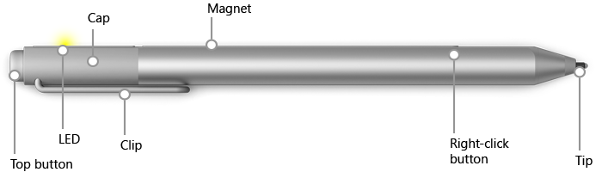
In this picture, we see the components that are used in a Surface Pro pen, a version of a digital pen. In most digital pens, most of these components are also included in order for the pen to function correctly. However, not all pens will have the multitasking button, which can be used as a right click button, just as a mouse, or can be used for other actions. A digital pen is very easy to use, the user starts by turning it on and then connects the Bluetooth of the computer to the pen, which the circuit board takes place in to connect them together. After, they are connected, the user is ready to take notes, draw or, etc.

Visuals
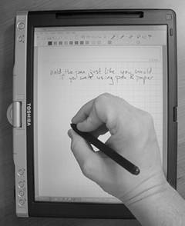

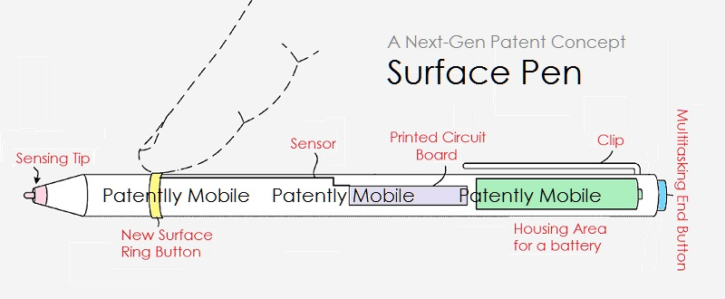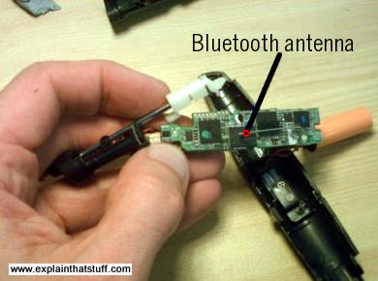
Conclusion
The first digital pen to ever exist was manufactured by Logitech, Inc. in 2003. However, this pen was different than modern times. Since computers at that time were not touchscreen, the pen functioned a bit differently. The pens had a small camera in them that detected what was being written on a surface and captured that image and uploaded it on the computer. However, today’s digital pens function differently since there are sensors in computers that allow the touch of a screen to be detected which is the technology used in today’s pens. Also, they never run out of ink, however, the older versions of digital pens needed ink.
An average digital pen as mentioned before cost ranges between $29.99 to $199.99 dollars. Also, to make sure your pen doesn’t die mid-way of using it, you should consider buying extra 4A batteries and always keep one at least with you at all times when you are using it. Or if the pen is rechargeable consider charging it before you go to sleep, just like phones so they don’t die while using them.

References
Matthews, Craig Forest. Absolute Beginner's Guide to Tablet PCs. Que, 2004. (IMG)
Purcher, Jack. “Microsoft Invents New Productivity Features for Future Surface Pens and Tablets.” Patently Mobile, Microsoft Patents, 7:35 AM, www.patentlymobile.com/2017/02/microsoft-invents-new-productivity-features-for-future-surface-pens-and-tablets.html (IMG)
Pierce, David. “Pens Are Making a High-Tech Comeback.” Wired, Conde Nast, 7 July 2015, www.wired.com/2015/07/the-pen-is-back/. (IMG)

